Django Delete Form

**Summary**: in this tutorial, you’ll learn how to create a Django delete form to delete a post.

This tutorial begins where creating [Django edit form](https://www.pythontutorial.net/django-tutorial/django-edit-form/) tutorial left off.

We’ll create a form that deletes a post by its id.

# Creating an URL pattern

Add an URL pattern to the pattern list in the urls.py of the blog application:

from django.urls import path

from . import views

urlpatterns = [

path('', views.home, name='posts'),

path('post/create', views.create_post, name='post-create'), path('post/edit/<int:id>/', views.edit_post, name='post-edit'), path('post/delete/<int:id>/', views.delete_post, name='post-delete'), path('about/', views.about, name='about'),

]

The delete URL accepts an id as an integer that specifies the id of the post to be deleted. When you open the URL:

<http://127.0.0.1/post/delete/1/>

Django will execute the delete_post() function in the views.py .

# Defining a view function

Define a delete_post() function in the views.py of the blog application:

from django.shortcuts import render,redirect, get_object_or_404 from django.contrib import messages

from .models import Post

from .forms import PostForm

def delete_post(request, id):

post = get_object_or_404(Post, pk=id) context = {'post': post}

if request.method == 'GET':

return render(request, 'blog/post_confirm_delete.html',context) elif request.method == 'POST':

post.delete()

messages.success(request, 'The post has been deleted successfully.') return redirect('posts')

*# ...*

How it works.

First, get the post by id using the get_object_or_404() and render the post_confirm_delete.html template. If the post doesn’t exist, then redirects to a 404 page.

Second, render the post_confirm_delete.html template if the HTTP request is GET.

Third, delete the post, [create a flash message](https://www.pythontutorial.net/django-tutorial/django-flash-messages/), and redirect to the post list if the HTTP request is POST.

# Creating a template

Create the post_confirm_delete.html template in the templates/blog directory of the

blog application. This template extends the base.html template of the project:

{% extends 'base.html' %}

{% block content %}

<h2>Delete Post</h2>

<form method="POST">

{% csrf_token %}

<p>Are you sure that you want to delete the post "{{post.title}}"?</p>

<div>

<button type="submit">Yes, Delete</button>

<a href="{% url 'posts' %}">Cancel</a>

</div>

</form>

{% endblock content %}

This template contains a form that has two buttons. If you click the submit button ( Yes, Delete ) it’ll send an HTTP POST request to the specified URL. Otherwise, it’ll navigate to the post list URL.

# Adding the delete link to the post

Add the delete link to each post in the home.html template:

{% extends 'base.html' %}

{% block content %}

<h1>My Posts</h1>

{% for post in posts %}

<h2>{{ post.title }}</h2>

<small>Published on {{ post.published_at | date:"M d, Y" }} by {{ pos

<p>{{ post.content }}</p>

<p>

<a href="{% url 'post-edit' post.id %}">Edit</a>

<a href="{% url 'post-delete' post.id%}">Delete</a>

</p>

{% endfor %}

If you open the URL <http://127.0.0.1/>, you’ll see the delete link that appears next to the edit link:

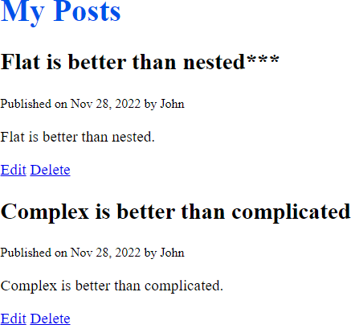

If you click the delete link, you’ll navigate to the delete URL. For example, the following shows the page when deleting the post with the title "Flat is better than nested***" :

Once you click the Yes, Delete button, Django will execute the delete_post() function that deletes the post and redirects you to the post list:

# Summary

Use the delete() method to delete a model from the database.